

**“GAS LEAKAGE DETECTOR USING ARDUINO WITH GSM MODULE”**

**A MINI-PROJECT REPORT**

***Submitted By:***

***Duddukuri Vaishnavi***

**Name of the Students**

**Duddukuri Vaishnavi(1NH17EC024)**

**Manisha.R(1NH17EC050)**

**Yathish.K(1NH16EC121)**

**Drshan Raj.S(1NH16EC022)**

***In partial fulfillment for the award of the degree of***

**Bachelor of Engineering**

**In**

**Electronics and Communication**

**Under the guidance of**

**Ms. Aneetha S Antony**

**Assistant Professor**

**Dept of ECE**

**NHCE, Bangalore**



Ring Road, Near Marathalli, Bangalore – 560 103, INDIA

Department of Electronics and Communication Engineering

**CERTIFICATE**

We certify that the project work entitled “**STUDY OF GAS LEAKAGE DETECTOR USING ARDUINO WITH GSM MODULE”** carried out by **Duddukuri Vaishnavi**, **Manisha.R, Yathish.K and Darshan Raj.S** bearing USN **1NH17EC024**, **1NH17EC050, 1NH16EC121** and **1NH16EC022**, a bonafide students of the **Department of Electronics and Communication Engineering**, in partial fulfillment for the award of Bachelor of Engineering in Electronics and Communication Engineering of the Visvesvaraya Technological University, Belgaum during the academic year **2020-2021**. It is certified that all corrections/suggestions indicated for Internal Assessment have been incorporated in the Report deposited in the departmental library. The project report has been approved as it satisfies the academic requirements in respect of project work prescribed for the said degree.

Ms. Aneeta S Antony Dr. Sanjeev Sharma

Assistant Professor Prof and HOD

ECE Dept, NHCE ECE Dept, NHCE

Bangalore Banglore

###### Name of the examiners Signature with date

1

2.



**ACKNOWLEDGMENT**

The satisfaction that accompanies the successful completion of task would be incomplete without mention of the people who made it possible, whose constant guidance and encouragement crown all efforts with success.

We would like to take this opportunity to express our profound gratitude to respected **Dr. Mohan Manghnani,** Chairman of New Horizon College of Engineering, for providing all the facilities in the college and respected Dr. **Manjunatha**, Principal, New Horizon College of Engineering, for his constant support.

We express our sincere gratitude to **Dr. Sanjeev Sharma**, Head of the Department of Electronics and Communication Engineering, New Horizon College of Engineering, for providing guidance and encouragement.

We would also like to thank our project guide **Ms. Aneetha S Antony**, Assistant Professor, Department of Electronics and Communication for his constant support and guidance. Gracious gratitude to all the faculty of the department of ECE for their valuable advice and encouragement.



**ABSTRACT**

LPG leakages are a mutual hindrance in household and manufacturing nowadays. It is very life threatening if you will not distinguish and modified right away. The idea behind our project is to give a solution by power cut the gas provision as soon as a gas leakage is perceived apart from activating the sounding alarm. In addition to this, the authorized person will receive a message informing him about the leakage with the increase of natural gas productions in the last 10 years: Philippines gas industry has really taken its toll. However, the Bureau of Fire Protection prompted the society to yield preventive and security measures against defective electrical cabling and dissolved petroleum gas leaks regardless of fire alarming.

Liquefied Petroleum Gas (LPG) is a main source of fuel, especially in urban areas because it is clean compared to firewood and charcoal. Gas leakage is a major problem in the industrial sector, residential premises, etc. Nowadays, home security has become a major issue because of increasing gas leakage. Gas leakage is a source of great anxiety with ateliers, residential areas and vehicles like Compressed Natural Gas (CNG), buses, and cars which are run on gas power. One of the preventive methods to stop accidents associated with the gas leakage is to install a gas leakage detection kit at vulnerable places. The aim of this paper is to propose and discuss a design of a gas leakage detection system that can automatically detect, alert and control gas leakage.



**CONTENTS**

**CHAPTER 1**

1.1 INTRODUCTION

1.2 OBJECTIVES

**CHAPTER 2**

2.1 COMPONENTS

2.2 DISECRIPTION OF COMPONENTS

2.3 CIRCUIT DIAGRAM AND WORKING

**CHAPTER 3**

3.1 ALGORITHM

3.2 CODING

**CHAPTER 4**

4.1 BENIFITS

4.2 CONCLUSION

4.3 PROPOSED METHODOLOGY, RESULT, FUTURE SCOPE AND REFERENCE



**CHAPTER 1**

* 1. **INTRODUCTION**
* Gas leakage is a serious problem and nowadays it is observed in many places like residences, industries, and vehicles like Compressed Natural Gas (CNG), buses, cars, etc. It is noticed that due to gas leakage, dangerous accidents occur.
* The Liquefied petroleum gas (LPG), or propane, is a flammable mixture of hydrocarbon gases used as fuel in many applications like homes, hostels, industries, automobiles, and vehicles because of its desirable properties which include high calorific value, less smoke, less soot, and meager harm to the environment.
* Liquid petroleum gas (LPG) is highly inflammable and can burn even at some distance from the source of leakage. This energy source is primarily composed of propane and butane which are highly flammable chemical compounds. These gases can catch fire easily.
* In homes, LPG is used mainly for cooking purposes. When a leak occurs, the leaked gases may lead to an explosion. Gas leakage leads to various accidents resulting in both material loss and human injuries.
* Home fires have been occurring frequently and the threat to human lives and properties has been growing in recent years.
* The risks of explosion, fire, suffocation are based on their physical properties such toxicity, flammability, etc.
* The number of deaths due to the explosion of gas cylinders has been increasing in recent years.
* The Bhopal gas tragedy is an example of accidents due to gas leakage.
* The reason for such explosions is due to substandard cylinders, old valves, no regular checking of gas cylinders, worn out regulators and a lack of awareness of handling gas cylinders.



* 1. **OBJECTIVES**
* The main objective of the proposed Gas Leakage Detection and Automatic Control System (GLDACS) is to provide a solution by designing an automatic system which can detect the leakage of liquefied petroleum gas (LPG) at home and control it by turning off the cylinder knob.
* At the same time the window of that room gets opened automatically using DC motor and an SMS alert will be sent to the owner of the house using GSM module.
* A number of reviews on the subject of gas leakage detection techniques were done in the past either as part of research papers/technical reports on a certain leak detection method and other gas related subjects.
* They proposed prototype depicts a mini mobile robot which is capable to detect gas leakage in hazardous places.
* Whenever there is an occurrence of gas leakage in a particular place the robot immediately read and sends the data to android mobile through wireless communication like Bluetooth.
* We develop an android application for android based smart phones which can receive data from robot directly through Bluetooth.
* The application warns with an indication whenever there is an occurrence of gas leakage and we can also control the robot movements via Bluetooth by using text commands as well as voice commands.
* The previous mobile robots are based on heterogeneous technologies like GSM, GPS, internet based etc., but the main disadvantage of those prototypes were the absence of communication in particular areas.
* So, with the rapid developments and tremendous changes in technology we have lots of techniques to eradicate previous problems.
* Wireless communication protocols play a vital role in present trends.
* Bluetooth, WI-Fi, Zigbee etc., we use one of the best feature of smart phone, i.e., the Bluetooth technology to control and monitor parameters driven by a robot.



**CHAPTER 2**

**2.1 COMPONENTS**

* ARDUINO MICRO CONTROLLER
* LIQUID CRYSTAL DISPLAY
* GSM MODULO WITH SYM
* MQ 135 GAS SENSOR
* BREAD BOARD
* 9V BUZZER



**2.2 COMPONENTS DISCRIPTION**

**ARDUINO MICRO CONTROLLER**

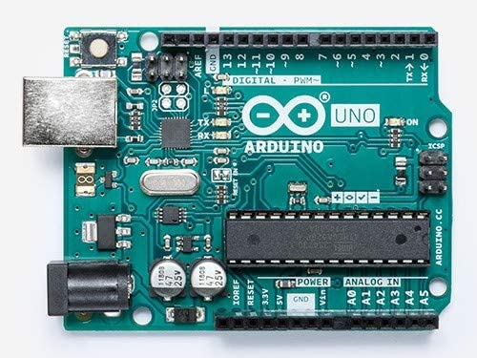

* **Arduino** is an open-source hardware and software company, project and user community that designs and manufactures single-board microcontrollers and microcontroller kits for building digital devices.
* Its hardware products are licensed under a CC-BY-SA license, while software is licensed under the GNU Lesser General Public License (LGPL) or the GNU General Public License (GPL)
* Permitting the manufacture of Arduino boards and software distribution by anyone. Arduino boards are available commercially from the official website or through authorized distributors.



**LIQUID CRYSTAL DISPLAY**

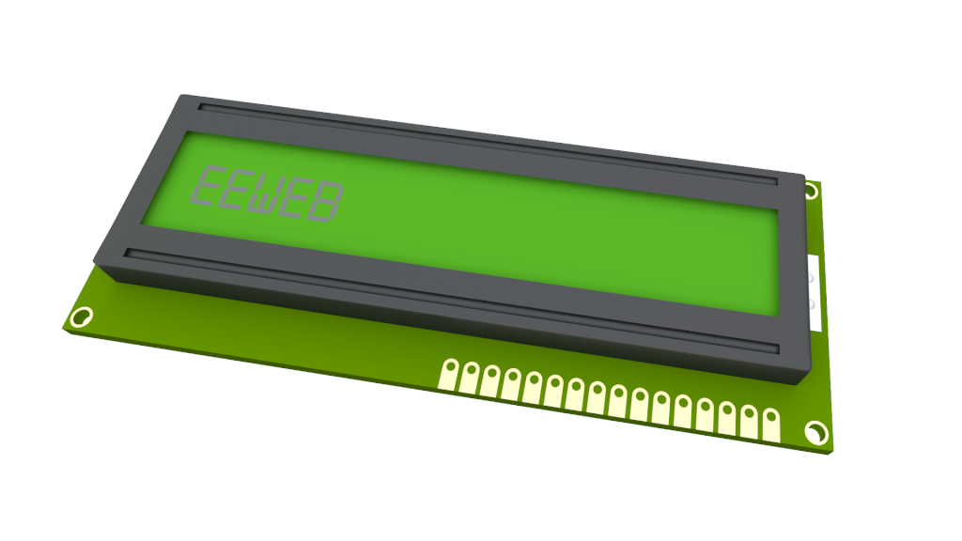

* A **liquid-crystal display** (**LCD**) is a flat-panel display or other electronically modulated optical device that uses the light-modulating properties of liquid crystals combined with polarizers.
* Liquid crystals do not emit light directly, instead using a backlight or reflector to produce images in color or monochrome.
* LCDs are available to display arbitrary images (as in a general-purpose computer display) or fixed images with low information content, which can be displayed or hidden, such as preset words, digits, and seven-segment displays, as in a digital clock.
* They use the same basic technology, except that arbitrary images are made from a matrix of small pixels, while other displays have larger elements.
* LCDs can either be normally on (positive) or off (negative), depending on the polarizer arrangement.
* For example, a character positive LCD with a backlight will have black lettering on a background that is the color of the backlight, and a character negative LCD will have a black background with the letters being of the same color as the backlight.



**GSM MODULE WITH SIM**

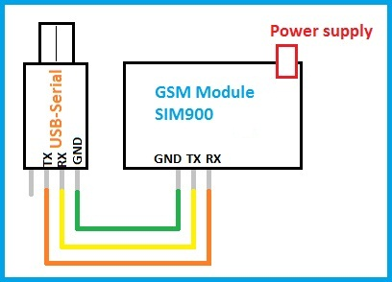

* **GSM modules** are fascinating to use especially when our project requires remote access. These modules could make all actions that our normal mobile phone could do, like making/receiving a call, sending/receiving a SMS, connecting to internet using GPRS etc.
* You can also connect a normal microphone and speaker to this module and converse on your mobile calls.
* This will open doors to lot of creative projects if it could be interfaced with a Microcontroller.
* Hence in this tutorial we will learn how we can **Interface the GSM module (SIM900A) with our PIC microcontroller**and will demonstrate it by making and receiving call using GSM Module.
* We have previously interfaced it with Arduino and Raspberry Pi for calling and messaging.



**MQ 135 GAS SENSORS**

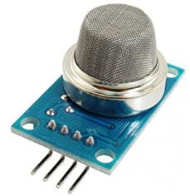

* Wide detecting scope
* Fast response and High sensitivity
* Stable and long life
* Operating Voltage is +5V
* Detect/Measure NH3, NOx, alcohol, Benzene, smoke, CO2, etc.
* Analog output voltage: 0V to 5V
* Digital output voltage: 0V or 5V (TTL Logic)
* Preheat duration 20 seconds
* Can be used as a Digital or analog sensor
* The Sensitivity of Digital pin can be varied using the potentiometer



**BUZZER**

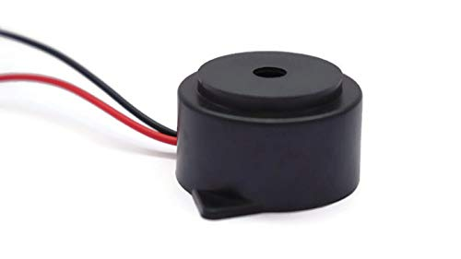

* The buzzer is a sounding device that can convert audio signals into sound signals. It is usually powered by DC voltage.
* It is widely used in alarms, computers, printers and other electronic products as sound devices.
* It is mainly divided into piezoelectric buzzer and electromagnetic buzzer, represented by the letter "H" or "HA" in the circuit.
* According to different designs and uses, the buzzer can emit various sounds such as music, siren, buzzer, alarm, and electric bell.



**BREAD BOARD**

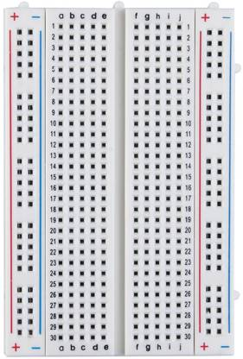

* Breadboards are one of the most fundamental pieces when learning how to build circuits. In this tutorial, you will learn a little bit about what breadboards are, why they are called breadboards, and how to use one.
* Once you are done you should have a basic understanding of how breadboards work and be able to build a basic circuit on a breadboard.



**2.3 CIRCUIT DIAGRAM**

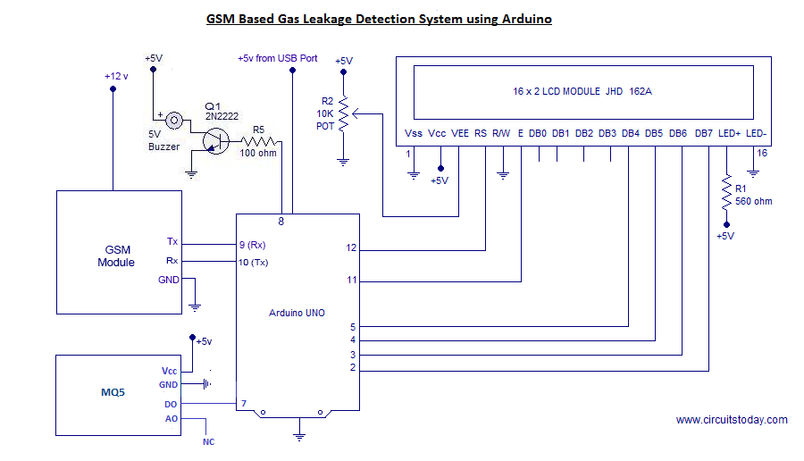

* Whenever there is LPG concentration of 300 - 1000 ppm in the atmosphere, the OUT pin of the sensor module goes high.
* This signal drives timer IC 555, which is wired as an astablemultivibrator. The multivibrator basically works as a tone generator.
* Output pin 3 of IC 555 is connected to LED1 and speaker-driver transistor SL100 through current-limiting resistors R5 and R4, respectively. LED1 glows and the alarm sounds to alert the user of gas leakage.
* The pitch of the tone can be changed by varying presetVR1.The MQ carrier board (Fig 4) is compatible with all MQ gas sensor models and reduces the six contacts to an easier to manage layout of three pins.
* The three pins are Vcc, Ground and Output.



**CHAPTER 3**

**3.1 ALGORITHM**

Step 1: Input

5V of VIN

Step 2: DETECTION OF GAS LEAKAGE

FROM MQ 135 GAS SENSOR

STEP 3: INITIALIZING

Buzzer Alert

OUTPUT: Buzzer Alert

LCD DISPLAY: Gas leakage Alert

“DANGER”



**3.2 CODING**

#include <LiquidCrystal.h>

LiquidCrystal lcd(3, 2, 4, 5, 6, 7);

#define lpg_sensor 18

#define buzzer 13

void setup()

{

pinMode(lpg_sensor, INPUT);

pinMode(buzzer, OUTPUT);

lcd.begin(16, 2);

lcd.print("LPG Gas Detector");

lcd.setCursor(0,1);

lcd.print("Circuit Digest");

delay(2000);

}

void loop()

{

if(digitalRead(lpg_sensor))

{

digitalWrite(buzzer, HIGH);

lcd.clear();

lcd.print("LPG Gas Leakage");

lcd.setCursor(0, 1);

lcd.print(" Alert ");

delay(400);

digitalWrite(buzzer, LOW);

delay(500);

}

else



{

digitalWrite(buzzer, LOW);

lcd.clear();

lcd.print(" No LPG Gas ");

lcd.setCursor(0,1);

lcd.print(" Leakage ");

delay(1000);

}

}



**CHAPTER 4**

**4.1 BENEFITS**

* It is used in house as LPG Leakage detection
* It also detects alcohol so it is used as liquor tester
* The sensor has excellent sensitive combine with a quick fast response time
* The system is highly reliable tamper-proof and secure
* In the long run the maintenance cost is very less when compared to the present system
* It is possible to get instantaneous results and with high accuracy

**4.2 CONCLUSION**

* Its ability to warn its stakeholders about the leakage of the LPG gas.
* The future aspects of this detector include the GSM module and a tripper circuit which increases the efficiency of the system and provides more safety to the users.
* This detector is implemented successfully and is easy to use and also a low cost product.
* Another advantage of this device is that even though if no one is there in the house and then gas leaks occurs, GSM module is there to send immediate messages to the stakeholders regarding the gas leak and thus it lowers the intensity of accidents.
* GSM module in this device ensures better safety regarding the gas leaks.



**4.3 PROPOSED METHODOLOGY**

* For the first stage project presentation the required research work has been completed and the validation of project has been proved.
* Hence it can be said that the aim of the project “LPG Gas Detection System Using GSM Module” can be achieved successfully.
* The further designing and fabrication of the working model will be completed by February 2016.
* After which the different experiments will be conducted for efficiency improvement.

**4.4 REFERENCES**

* T. Murugan, A. Periasamy and S. Muruganand, “Embedded Based Industrial temperature monitoring system using GSM”, International Journal of computer applications.
* V. Ramya and B. Palaniappan, “Embedded system for Hazardous gas detection and Alerting,” in Proc. of International Journal of Distributed and parallel system (IJDPS), vol. 3, no. 3, May 2012.
* L. Solis, Y. Li and L. B. Kishs, “Fluctuation-Enhanced Multiple-gas sensing by Commercial Taguchi Sensor,”IEEE Sensor Journal, vol. 5, no. 6, Dec 2005.
* H. G. Rodney Tan, C. H. Lee and V. H. Mok, “Automatic Power Meter Reading System Meter Reading Using GSM Network,” in Proc. of the 8 Th International Conference.
* H. Huang, H. Bainand S. Zhu, “A Greenhouse Remote Monitoring System Based on GSM,” in Proc. of IEEE International Conference on information management.
* A Jain, D. Kumar and J. Kedia, “Design and development of GSM based energy Meter, “International Journal of Computer Application, vol. 47, no. 12, June 2012.